**Project ID:**

TMP-2023-24-074

**Important instructions to students:**

1. **According to the comments given by the supervisor, make the necessary modifications and finally, get the approval from the Supervisor and the co-supervisor.**
2. **If the project topic is rejected, identify a new topic, and follow the process as before.**
3. **The approved form must be submitted to the folder (will be notified later) on or before 10th July 2023.**

**(Students should ensure that they complete all sections ranging from 1 to 7. Then, download the form and email to your supervisor before 26th June 2023. Please note that the corresponding supervisor of the project is responsible for completing sections 8 to 10.)**

1. Topic (12 words max)

Enhancing Sustainable Crop Protection through Machine Learning-Driven Integrated Strategies

1. Research area the project belongs to

**Machine Learning and Soft Computing (MLSC)**

1. Team member details

|  |  |  |
| --- | --- | --- |
| Student Name | Student ID | Specialization |
| Leader: Senanayake P.M. | IT20606756 | DS |
| Member 2: Withanage P.W.E.L. | IT20600334 | DS |
| Member 3: Wijesinha W.S.S | IT20641092 | SE |
| Member 4: Anuththara R.M.C | IT20637064 | SE |

1. Brief description of the research problem including references (200 – 500 words max) – references not included in word count.

# The research project at hand focuses on pest control in agriculture, with a specific emphasis on addressing the issue of crop damage caused by various agricultural pests. Among the pests that pose significant challenges, monkeys, wild boars, peacocks, wild elephants, and porcupines have been identified as the most problematic offenders. However, it is crucial to note that apart from these animals, crops also face a range of diseases caused by insects and deficiencies, which further complicate the situation.

# In the village being studied, residents grapple with the persistent threat of pests that ravage their crops. Monkeys have emerged as a significant problem, inflicting direct losses on fruits, vegetables, grains, and flowers. Their foraging activities, such as trampling and knocking down plants, exacerbate the situation, leading to substantial financial losses for farmers who rely on these crops as their primary source of income.

# In addition to monkey damage, the community faces a host of challenges associated with diseases caused by insects and other animals. Crops are susceptible to various insect pests, including aphids, caterpillars, and beetles, which can inflict severe damage by feeding on leaves, fruits, and roots. These pests not only reduce crop yields but also compromise the quality of harvested produce. Moreover, diseases caused by viruses, bacteria, and fungi further add to the woes of farmers, making it difficult to identify the specific diseases and find immediate solutions.

# The impact of these agricultural pests and diseases is profound, as farmers struggle to protect their crops and maximize production. Financial losses incurred due to crop damages affect the livelihoods of individuals and the overall economic well-being of the community. Consequently, addressing these issues and finding effective solutions becomes imperative to ensure the sustainability of agricultural practices in the village.

# The research project aims to identify and implement appropriate pest control measures that can mitigate the damages caused by monkeys and other agricultural pests. This includes exploring integrated pest management techniques, such as the use of physical barriers, scare devices, and repellents, as well as implementing sustainable farming practices to minimize pest infestation. Furthermore, the research team will investigate disease management strategies to identify and mitigate the impact of insect-borne and deficiency-related diseases. This may involve the use of targeted insecticides, crop rotation, breeding resistant crop varieties, and implementing proper nutrient management practices to address deficiencies.

# By addressing the multifaceted challenges of crop damage caused by pests and diseases, the research project aims to provide farmers with practical and sustainable solutions that can maximize crop production. Through the implementation of effective pest control and disease management strategies, the project seeks to alleviate the financial burden on farmers and contribute to the overall agricultural prosperity and well-being of the community.

# References

[1] Author(s). (2023, May 2). Human Monkey Conflict: The Reasons and Mitigation Strategies. [Online]. Available: <https://www.sjp.ac.lk/blog/human-monkey-conflict-the-reasons-and-mitigation-strategies/>

[2] Rodrigo, M. (2023, March 21). As crop-raiding animals reach an all-time high, food-crisis hit Sri Lanka looks for solutions. [Online]. Available: <https://jnsfsl.sljol.info/articles/abstract/10.4038/jnsfsr.v39i4.4144/>

[3] "Crop damage by wild animals: Monkey sterilisation causes concern," The Morning, 26th June 2023. [Online]. Available: <https://www.themorning.lk/articles/117964>

# References-

[1] Author(s). (2023, May 2). Human Monkey Conflict: The Reasons and Mitigation Strategies. [Online]. Available: https://www.sjp.ac.lk/blog/human-monkey-conflict-the-reasons-and-mitigation-strategies/

[2] Rodrigo, M. (2023, March 21). As crop-raiding animals reach an all-time high, food-crisis hit Sri Lanka looks for solutions. [Online]. Available: <https://jnsfsl.sljol.info/articles/abstract/10.4038/jnsfsr.v39i4.4144/>

[3] "Crop damage by wild animals: Monkey sterilization causes concern," The Morning, 26th June 2023. [Online]. Available: https://www.themorning.lk/articles/117964

1. Brief description of the nature of the solution including a conceptual diagram (250 words max)

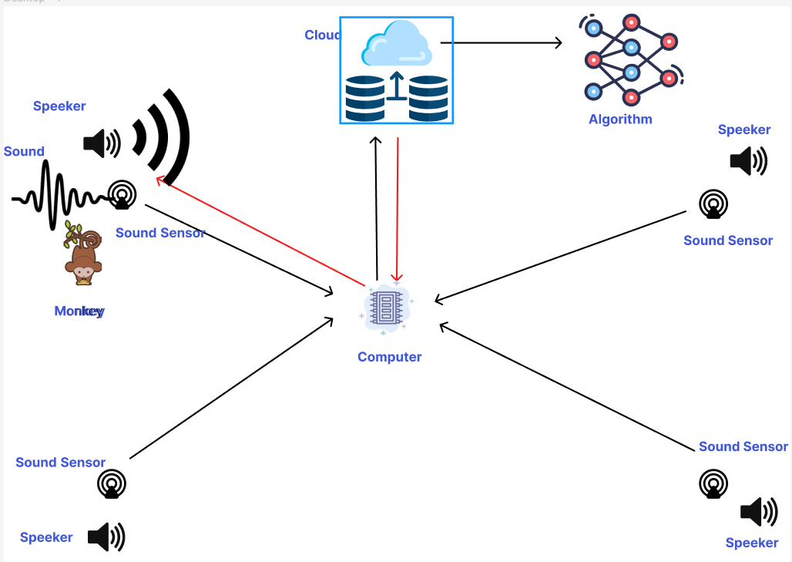

In several villages, farmers are facing a significant issue of monkeys damaging their crops. The current method employed to drive away the monkeys involves shooting, which is ineffective when dealing with a large herd of monkeys. Moreover, this approach poses risks to animal lives. In response, a more humane and effective system is proposed to drive away these animals and mitigate crop damage.

To address the issue of monkeys encroaching on our land, we have devised a solution involving a sound system. Sound sensors strategically positioned throughout the area detect the monkeys' arrival by analyzing their distinct sounds. Advanced algorithms quickly process the data, distinguishing monkey vocalizations from other noises. Once the presence of monkeys is confirmed, speakers emit high-frequency and high-decibel sounds designed to deter them from staying on our property. This comprehensive system not only detects and repels monkeys but also identifies patterns in their entry and exit behavior. By analyzing this data, we gain insights into their movement patterns and preferred entry points, allowing us to optimize our preventive measures. This proactive approach effectively protects our land and offers a long-term solution to the monkey problem.

And mobile application provides a solution to the problem of tree diseases causing reduced crop productivity. It allows users to capture images of affected trees, which are then processed and analyzed using image recognition and machine learning algorithms. The app classifies the presence of specific diseases and provides users with accurate identification, along with relevant information and recommended actions from a comprehensive disease database. Additional features include real-time disease monitoring, prevalence mapping, and data sharing among users. By empowering farmers with timely and accurate disease identification, the app helps mitigate the impact of tree diseases on crop productivity in a user-friendly and accessible manner.

1. Brief description of specialized domain expertise, knowledge, and data requirements (300 words max)

Specialized Domain Expertise:

1. Monkey Sounds:

* Expertise in acoustics and animal vocalizations to accurately identify and differentiate various monkey sounds.
* Understanding the distinct vocal patterns and frequencies associated with different monkey behaviors or expressions.

2. Distance Detection:

* Knowledge of sensor technologies and signal processing techniques to detect the distance between the monkey and the input device.
* Understanding of the relationship between distance and sound propagation to emit a corresponding decibel frequency.

3. Monkey Behavior Patterns:

* Expertise in primatology and animal behavior to identify and interpret patterns in monkey behavior.
* Understanding the factors influencing monkey behavior, such as feeding patterns, social dynamics, and response to stimuli.

4. Tree Diseases and Crop Productivity:

* Specialized knowledge in plant pathology and agronomy to identify tree diseases that affect crop productivity.
* Understanding the symptoms, causes, and impacts of specific diseases on different crops.
* Familiarity with disease management strategies and preventive measures.

Data Requirements:

1. Monkey Sounds:

* A dataset of monkey sound recordings with annotated labels representing different vocalizations.
* Additional contextual data, such as time of recording, environmental conditions, and monkey species.

2. Distance Detection:

* Sensor data capturing the distance between the monkey and the input device.
* Calibration data mapping distance measurements to corresponding decibel frequencies.

3. Monkey Behavior Patterns:

* Long-term observational data tracking monkey behavior in various contexts, including agricultural landscapes.
* Environmental data, such as weather conditions and vegetation dynamics, to assess correlations with monkey behavior.

4. Tree Diseases and Crop Productivity:

* Comprehensive dataset of tree diseases, including images or symptom descriptions, causes, and impacts on crop productivity.
* Historical crop yield data and associated disease outbreaks to identify patterns and correlations.

The specialized domain expertise required includes knowledge of monkey vocalizations, sensor technologies for distance detection, primatology for understanding behavior patterns, and plant pathology for tree diseases. Access to relevant datasets of monkey sounds, distance measurements, observational data, and tree disease information is essential for training machine learning models and conducting data analysis. By combining expertise, knowledge, and data, the research aims to develop effective solutions to mitigate crop damage caused by monkeys while promoting sustainable agriculture.

1. Objectives and Novelty

|  |  |  |  |
| --- | --- | --- | --- |
| Main Objective  We are developing a web and mobile application aimed at reducing harm caused by animals and diseases. Our app provides vital information, real-time updates, and valuable resources to enhance crop protection and increase productivity. Our mission is to empower users with effective strategies for agricultural sustainability and harmonious cohabitation with nature. | | | |
| Member Name | Sub Objective | Tasks | Novelty |
| 1) | * Analyze the different input data and identify the different monkey sounds. | 1. Getting the input data from the device and saving it in a cloud. 2. Implement the model by developing the algorithm and detect the input as a monkey noise.  * Preprocess the audio data to extract relevant features that can help distinguish between monkey noises and other sounds. * Implement a machine learning algorithm to classify audio as monkey noise or non-monkey noise for effective detection. * Deployment and real-time detection | The farmer will receive an immediate alert from the monkey detection system once the distinct monkey sounds are identified. |
| 2) | * Detects the distance between the monkey and the input device and emits a sound of the corresponding decibel frequency. | 1. Calculating the distance between the target and the input device using an accurate calculations method. 2. By studying how the decibels frequency changes depending on the distance, create a data set and predict the correct appropriate frequency for the distance.  * Creating the dataset from the data obtained by releasing the output sound by changing the frequency from time to time according to the distance. * Implement a machine learning algorithm to predict the most suitable decibel frequency to chase the monkeys away.  1. Releasing sound through an output device with the relevant frequency. | If the monkey noise continues to be captured despite outputting the output sound, emit a special sound for it. |
| 3) | * Identify the patterns of the monkey’s behavior by using input data | 1. Implement a model by creating a machine learning algorithm and predict the monkey’s behavior.  * Create the dataset by collecting the data from the monkey's arrival times and behavior by studying the data received in a certain period of time. * By studying the dataset, give a prediction to the farmer about their arrivals or behavior in future periods. * Give the farmer a broad idea about the monkey's visitation patterns in the past intervals. | Give a warning to the farmer by identifying the areas with high risk of monkey's arrival. |
| 4) | * Increasing the productivity of cultivation by identifying the diseases present in cultivated crops | 1. Train a deep learning model on image dataset and predict the diseases of the cultivated crops.  * Gather a dataset of images specific to diseases of the crop. Label each image with the corresponding disease type. * Utilize a deep learning architecture, such as a convolutional neural network (CNN), to train a model on the labeled image dataset. * Train the model and identify the diseases. | Based on the predicted disease, offer appropriate solutions and recommendations to the user. |

1. **Supervisor checklist (supervisors should fill sections from 8 to 10)**
2. Is this research problem valid?

|  |  |  |  |
| --- | --- | --- | --- |
| Yes |  | No |  |

1. Is the proposed research group, correct?

|  |  |  |  |
| --- | --- | --- | --- |
| Yes |  | No |  |

1. Is the proposed research area, correct?

|  |  |  |  |
| --- | --- | --- | --- |
| Yes |  | No |  |

1. Do the proposed sub-objectives match the students’ specialization?

|  |  |  |  |
| --- | --- | --- | --- |
| Yes |  | No |  |

1. Is the required domain expertise, knowledge, and the data available either through the supervisor or external supervisor?

|  |  |  |  |
| --- | --- | --- | --- |
| Yes |  | No |  |

1. Is the scope of the solution practical?

|  |  |  |  |
| --- | --- | --- | --- |
| Yes |  | No |  |

1. Do all sub-objectives have sufficient novelty?

|  |  |  |  |
| --- | --- | --- | --- |
| Yes |  | No |  |

1. Your final decision:

Acceptable : Mark/Select as necessary

|  |  |
| --- | --- |
| Topic Accepted |  |
| Topic Accepted with minor changes (should be followed up by the supervisor) * |  |
| Topic to be Resubmitted with major changes* |  |
| Topic Rejected. Topic must be changed |  |

* Detailed comments given below

Comments

1. Supervisor details

|  |  |  |  |  |
| --- | --- | --- | --- | --- |
|  | Title | First Name | Last Name | Signature |
| Supervisor |  |  |  |  |
| Co-Supervisor |  |  |  |  |
| External Supervisor |  |  |  |  |
| Summary of external supervisor’s (if any) experience and expertise | | | | |